**UNH SEDS**

**Final Launch Report**

October 2018



Authors

Charlie Nitschelm, Reilly Webb, Thomas Collins,

Grace Johnston, Silas Johnson, Charles Gould, Ross Thyne,

Matt Dodge, Ester Yee, Carly Benik, Samantha Brady,

Andrew Hosman, Chase Eldredge, Collin Stroshine,

John Langer, Ryan Blatti, Tyler Landry

Advisor

Dr. Todd Gross

Table of Contents

List of Figures 2

List of Tables 3

Introduction 4

Abstract 4

Objectives of UNH SEDS 4

University Student Rocketry Competition 4

Goals 5

Constraints 5

Overall Rocket Configuration and Concept of Operations 5

Competition Flight Overview 6

Safety and Launch Procedure Checklist 7

Launch Operations and Safety Precaution Checklist 7

Results Analysis 8

Material Choice 9

Engine Choice 9

Parachute Choice 9

Failure Analysis 10

Improvement Cycle for Failure Mitigation 10

Competition Launch Failure Analysis 11

Multimedia Documentation 12

YouTube Links 12

Notable Pictures 12

APPENDIX 15

MATLAB Simulation Code 15

Launch Simulation (Parent Function) 15

Get Acceleration 15

Get Acceleration 2 15

Get Thrust 15

Get Mass 15

Get Drag 15

Get Drag 2 15

# List of Figures

# List of Tables

# Introduction

## Abstract

Members of UNH SEDS are designing, manufacturing, and launching a high powered multi-stage rocket for the SEDS University Student Rocketry Competition. Collegiate rocketry teams will be competing nationally in the Fall of 2018, with points awarded to the rockets that achieve the highest altitude, are fully recoverable, and are backed by the strongest design methodology. Since our team is working from the ground up, UNH SEDS has taken a "first principles" approach towards reaching these goals. Once fundamental aerodynamic relationships were studied and understood, they were implemented to create models of flight dynamics, drag, and stability. A static test fire rig was constructed to obtain experimental thrust curve data from the engines; further increasing the accuracy of our simulated trajectories. Driven by both manufacturing and competition constraints, our models were then used to optimize nose cone, body tube, and fin dimensions. Eight rocket iterations have been designed and launched. We have analyzed the flight data from each launch to continuously improve and learn important lessons out in the field that could not have been gathered from theory and simulations alone. The bulk of this report is to give a detailed view of taking our final rocket design into manufacturing, the problems encountered, and a greater detailed view in ensuring a safe, reliable flight.

## Objectives of UNH SEDS

Students for the Exploration and Development of Space (SEDS) is a national, student-based organization that enables university students to get involved in space related projects. A chapter of SEDS has was founded at UNH in the Fall of 2017.

The mission of UNH SEDS is to provide a platform for UNH students to form multi-disciplinary teams and pursue space-focused outreach, networking events, and engineering projects.

The 2017-2018 school year and the beginning of the Fall semester of 2018 was dedicated to design a rocket to compete in the University Student Rocketry Competition in October 2018. Students from all classes and majors dedicated themselves to learn the insider view of high power rocketry to be able to place with some of the top rocketry team in the country.

## University Student Rocketry Competition

The USRC is an annual competition hosted by SEDS-USA to challenge students, to design, build, and launch a multi-stage rocket with a standardized altimeter to the highest possible altitude. The judging panel includes professionals from within the aerospace industry. Winning teams will be awarded a cash prize as well as free attendance to the SEDS SpaceVision 2018 conference. Teams can launch at a field close to their university as long as they are witnessed by an independent party. However, teams can also meet up to organize a regional launch. Points are awarded by the judges based on the following criteria:

### Goals

1. Design and launch a high-powered rocket to achieve **maximum altitude** (at least 3000 feet)
2. Implement a comprehensive recovery system, such that the rocket is fully reusable

### Constraints

1. Total combined engine impulse must not exceed **640.0 N-s**
2. The rocket must have *at least* two propulsive stages
3. Time: Launch window closes **October 12th, 2018**
4. Budget: $4563.0 from the UNH ME department and Parents Association

## Overall Rocket Configuration and Concept of Operations

A section-view model of the rocket configuration is shown below in Figure 1. This is a high-level description of the major components that will be frequently referenced throughout the remainder of the report.

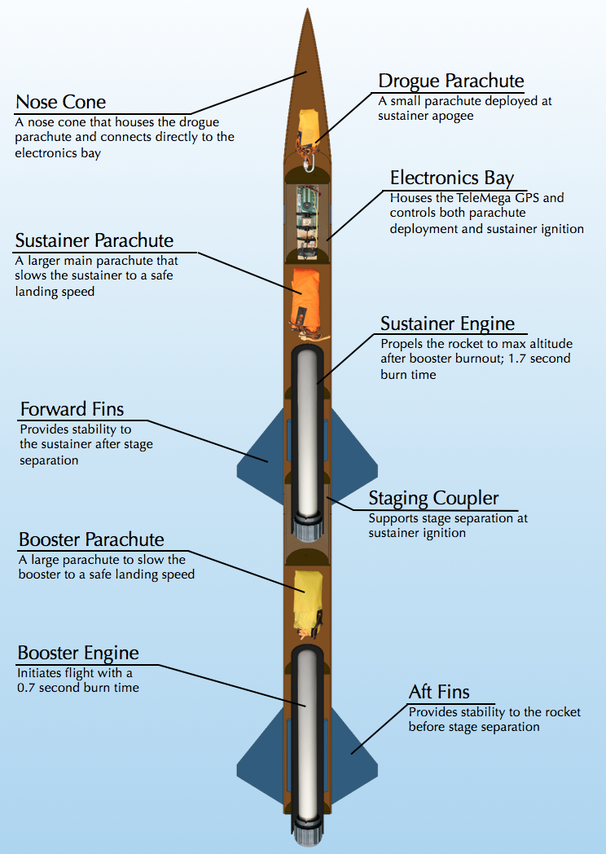

Figure 1. Rocket Components

Both engines are solid-propellant rocket motors manufactured by Cesaroni. Solid engines were chosen for simplicity and were purchased instead of being custom built. Next year UNH SEDS will attempt to manufacture their own hybrid rocket engines.

The TeleMega GPS/Altimeter system used will be referred to as the flight computer. The flight computer, which was moved to the nosecone, sends electrical signals at various preprogrammed events. Current is sent to two individual ignitors; one that initiates the firing of the sustainer engine and one that lights ejection charges for deploying the parachutes.

The booster engine is the first engine to fire; ignited manually from a safe distance using a custom ignition switch. Booster burn-out is followed be stage separation, then sustainer ignition. Decoupling the two stages is achieved by drag separation, with increased pressure from sustainer ignition acting as a fallback. The booster parachute then deploys, carrying the booster body tube and booster engine safely to the ground.

The sustainer body tube continues upward until the rocket reaches a maximum altitude. The sustainer then free falls until it reaches a certain height (300m). At this predetermined altitude, the flight computer will send a signal to another ejection charge located in the aft end of the nosecone. This separates the sustainer body tube from the nosecone and deploys the main parachute; a large parachute that slows the rocket components considerably. This prevents significant damage from ground impact.

# Competition Flight Overview

When the team arrived at the launch field, sky conditions were nominal. Winds at the ground were at a low for the day (4 m/s), but winds near our simulated apogee were nearly 10m/s. The NAR South Berwick field usually has large crosswinds, which is the primary reason we changed our competition rocket design to utilize a single parachute deployment at 300 meters, allowing the rocket to free fall from apogee. We used a launch angle of 10 degrees to help compensate for the wind, as recovery is very important for the competition.

Once the rocket was prepped and confirmed for launch, the launch safety officer was concerned with allowing our sustainer free fall from such a high altitude (2,215 meters) with the risk of parachute deployment not working. A chute release was donated to us at the field so we can separate at apogee with the main parachute acting as a streamer, and opening up at 300 meters via the chute release. We were hesitant in changing our flight mechanics to utilize the chute release because of our inexperience with ever using that electronic system. It would make rocket drift due to wind an unknown problem that could not be simulated in time. We respected the wishes of the safety officer and agreed to use the chute release for flight.

We went through our safety and launch procedure checklist to prepare our rocket for its competition launch. The countdown began, boiling the entire organizations work into just 10 seconds. The booster ignited with double the thrust our team has ever flown, launching the rocket off the launch pad. A less optimal booster engine needed to be used (H159) instead of the desired H399 because of commercial availability at the time. With this change, we were calculating less then optimal take off velocities, resulting in instability at the beginning of our launch. This instability altered our flight trajectory, changing the tilt angle of the rocket significantly before sustainer ignition. The team froze as the booster cutoff, hoping that the adventure is not over. Then, 2.9 seconds after booster cutoff, the sustainer lit with a fiery road that carried our sustainer to its apogee of 2,215 meters. The delay time between booster engine cutoff and sustainer engine ignition was calculated to be 2.0 seconds for maximum height. The sustainer engine took an extra 0.9 seconds to start, which led to less than optimal sustainer ignition.

Recovery has never been the teams’ strong suit, but this launch was different. The booster was recovered with complete reusability as seen in the footage linked near the end of this report. The sustainer, which its recovery methods were altered last minute, ended with a different fate. The apogee event was nominal, releasing the main parachute out of the body tube still wrapped in the donated chute release. This resulted in a descent speed much slower then what would have been seen if the rocket were to free fall. This decrease in descent and increase in flight time resulted in a large drift away from the launch pad. We traveled to the coordinates of where the TeleMega last recorded the location of the rocket only to find that it had landed in the middle of a small lake. The electronics were lost and certainly waterlogged but the TeleMega still transmitted all of our flight data to our launch software. The SEDS altimeter went down with the sustainer, not allowing us to verify the beeping apogee of the rocket. Our personal flight computer received all the data of the flight that is needed to analyze the launch and more. We hope that you still consider our TeleMega data due to this unfortunate landing. The raw date file will be sent with this report to prove that no foul play has been involved with our report.

Overall, our launch was successful. It reached an apogee that had surpassed previous competition winners and our flight data was recovered. Although the sustainer was not recovered from the lake, we are confident that its descent speed was slow enough to have been fully recoverable if it did not land in water, which it was not designed to encounter.

# Safety and Launch Procedure Checklist

## Launch Operations and Safety Precaution Checklist

1. Assemble Launch Pad in desired location given the rocket flight path, wind direction and field orientation
   1. The wind was strong, so an angle of attack was implemented to compensate for environment conditions.
   2. Set up the launch rail stopper to raise the rocket roughly 6 inches above the launch pad base
   3. Slide rocket into position on rail
2. Turn on the Telemega GPS to begin satellite connection and flight configuration
   1. Ensure battery is fully charged and correct beeps sound when switch is flipped on
3. Turn on SEDS Altimeter by connecting the terminals on the side
   1. Ensure correct beeps upon startup
4. Insert the booster engine assembly into the booster
   1. Ensure that there are no possible situations that can ignite the booster engine when configuring on the launch pad
5. Screw rocket aft retainer onto engine tube
6. Remove yellow safety cap to begin igniter installation
   1. Ensured that the range safety officer and the launch director are the only ones at the launch controller to limit any risk of preemptive ignition
   2. All other members and observers must be 100 feet away from the rocket
7. Install igniter leads into engine by inserting through the nozzle and up the grain until it reaches the top
8. Screw engine casing retainer onto the booster engine tube to constrain the engine in both the positive and negative y directions
9. Attach igniter leads onto the launch system alligator leads.
   1. Checked that the other igniter launch leads are not connected to the battery and the launch director has the launch key
10. Insert the sustainer engine assembly into sustainer engine tube.
    1. Ensured that there are no possible situations that can ignite the sustainer engine when configuring on the launch pad
11. Screw rocket aft retainer onto engine tube
12. Remove yellow safety cap to being igniter installation
13. Install pre-installed igniter leads from e-bay into the engine.
    1. Insured proper lead connections between the e-bay and ignitor wire
14. Install igniter leads into engine by inserting through the nozzle and up the grain until it reaches the top of the engine.
15. Screw engine casing retainer onto the sustainer engine tube to constrain the engine in both positive and negative y direction
16. Re-attach sustainer, coupler, and booster tubes.
17. Perform final checks on the rocket
    1. Fin alignment between stages
    2. Proper retainment on all engines
18. Run from launch pad (It is UNH SEDS tradition to always run from the launch pad before countdown)
19. Verify TeleMega connection, continuity on all igniters and GPS tracking
20. Setup launch controller to the battery for launch
21. Verify surroundings and safety of all people
    1. Launch safety officer gave the okay for launch
22. Check continuity
23. Countdown
24. Launch

# Results Analysis

The following analysis of our launch results compares our real, experimental data taken at launch with our homemade, in-depth MATLAB simulation of a multi-stage rocket. OpenRocket, which is a widely accepted rocket launch simulation software, is also compared to lay a framework of how our simulations compare with what is commonly accepted accurate.

## Height vs. Time Analysis

Carbon fiber offers a lightweight and strong selection for material, despite its material cost. All major

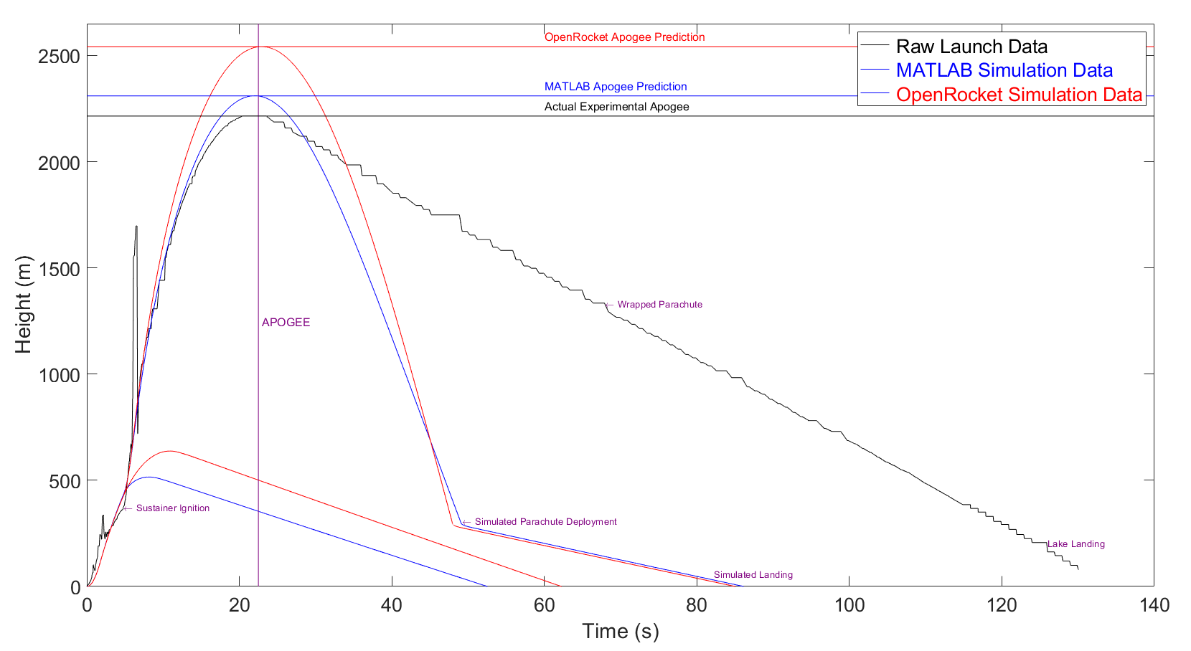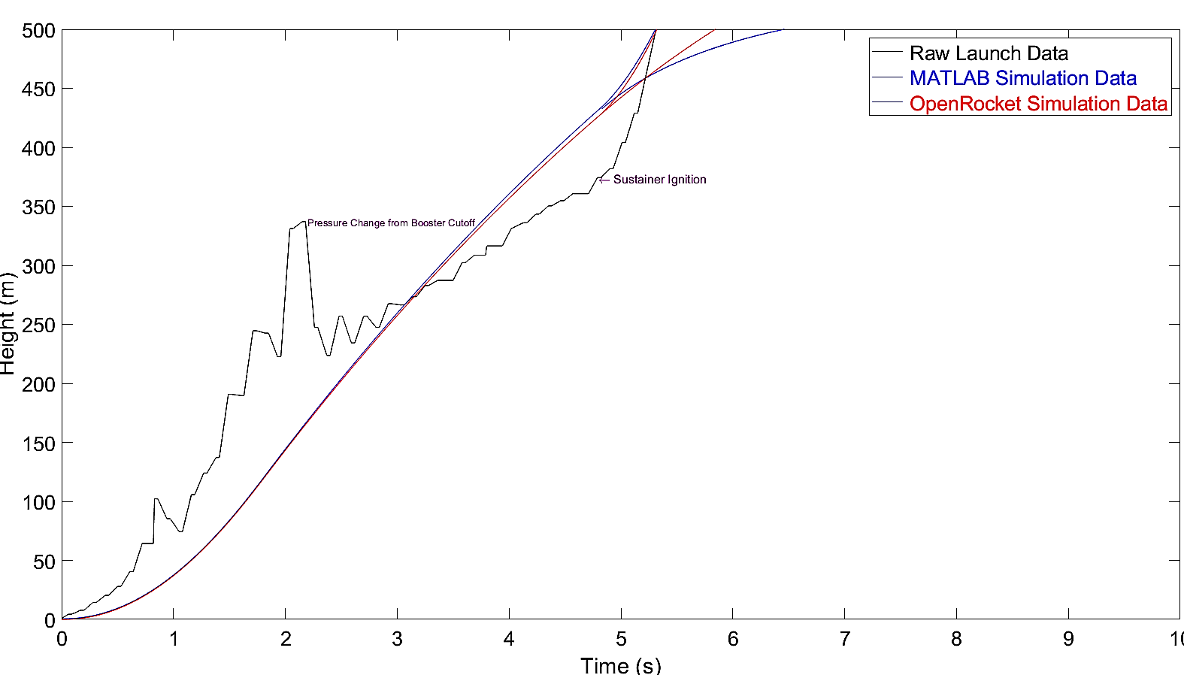

## Velocity vs. Time Analysis

The engines that have been used to increase our body of knowledge in rocketry were G class. The

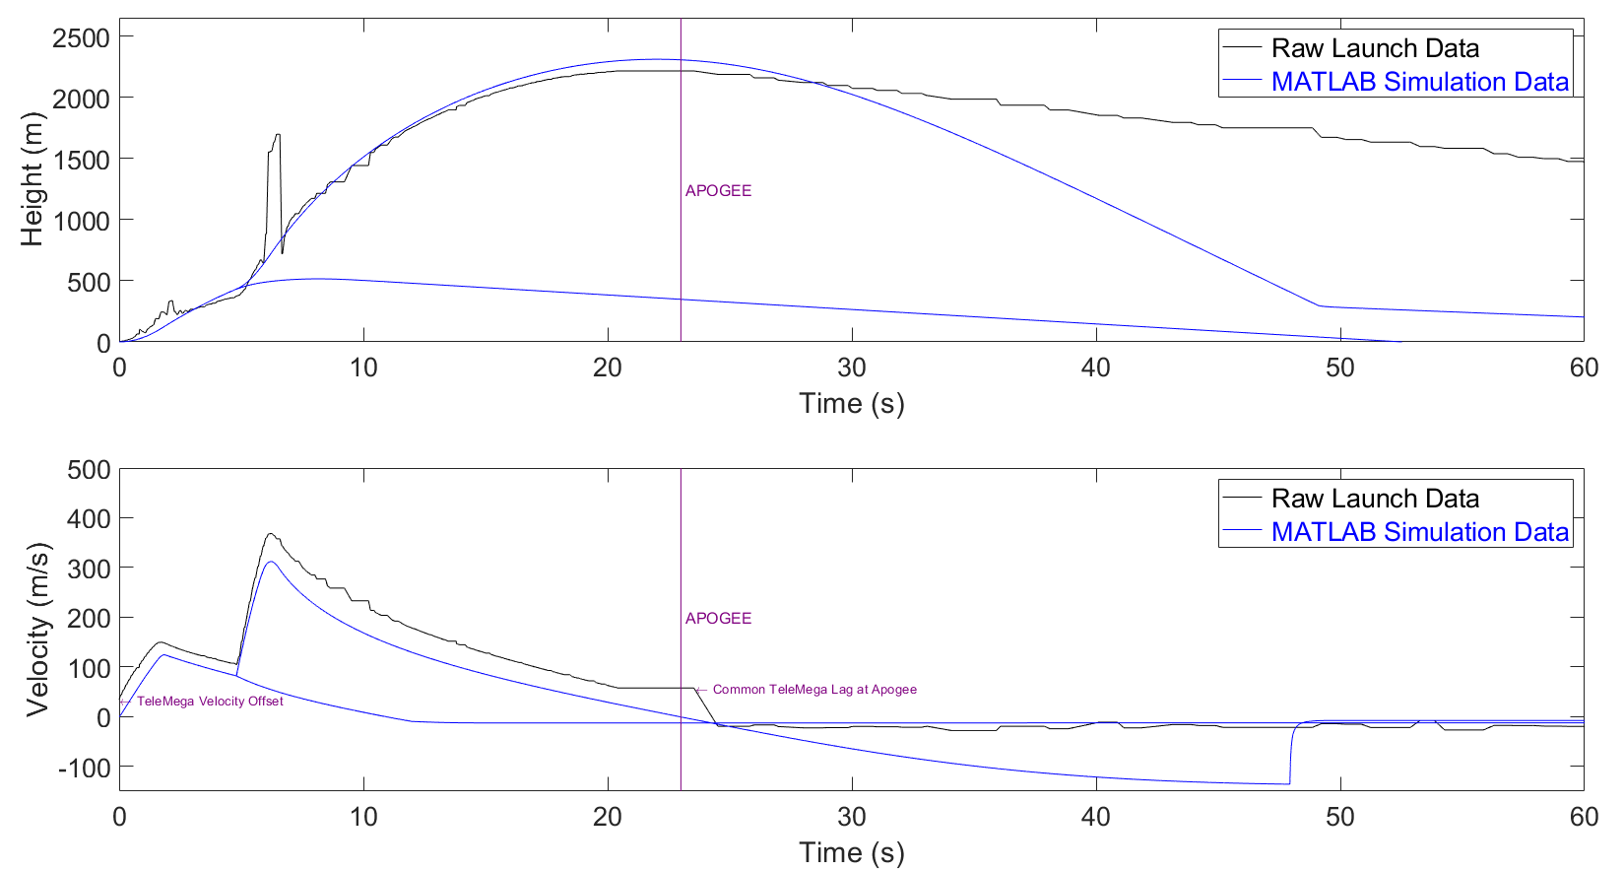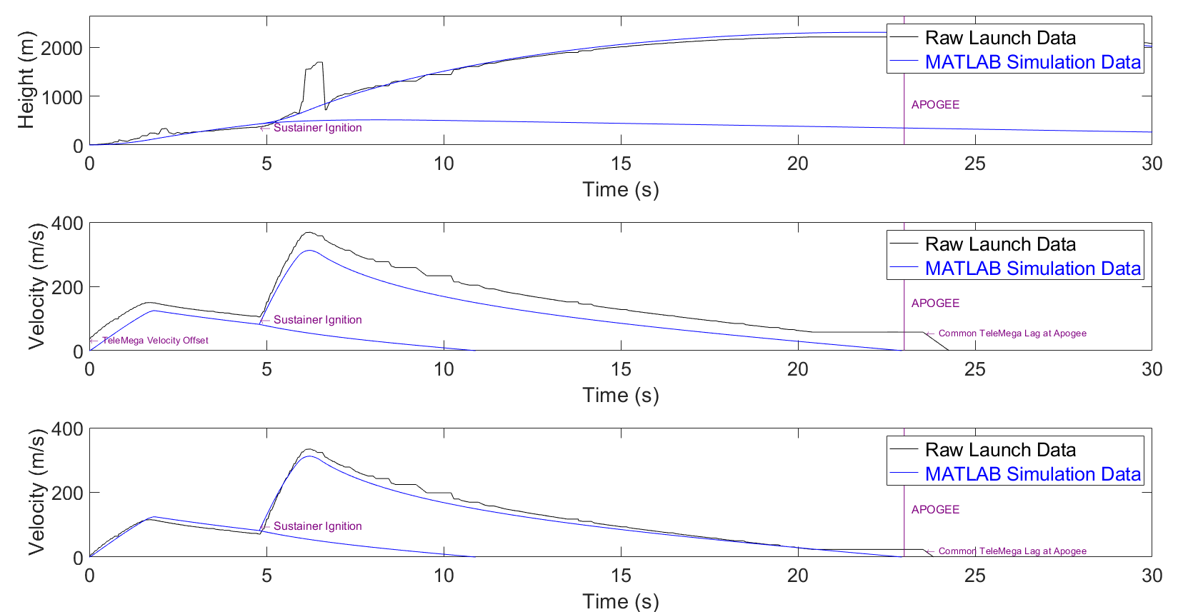

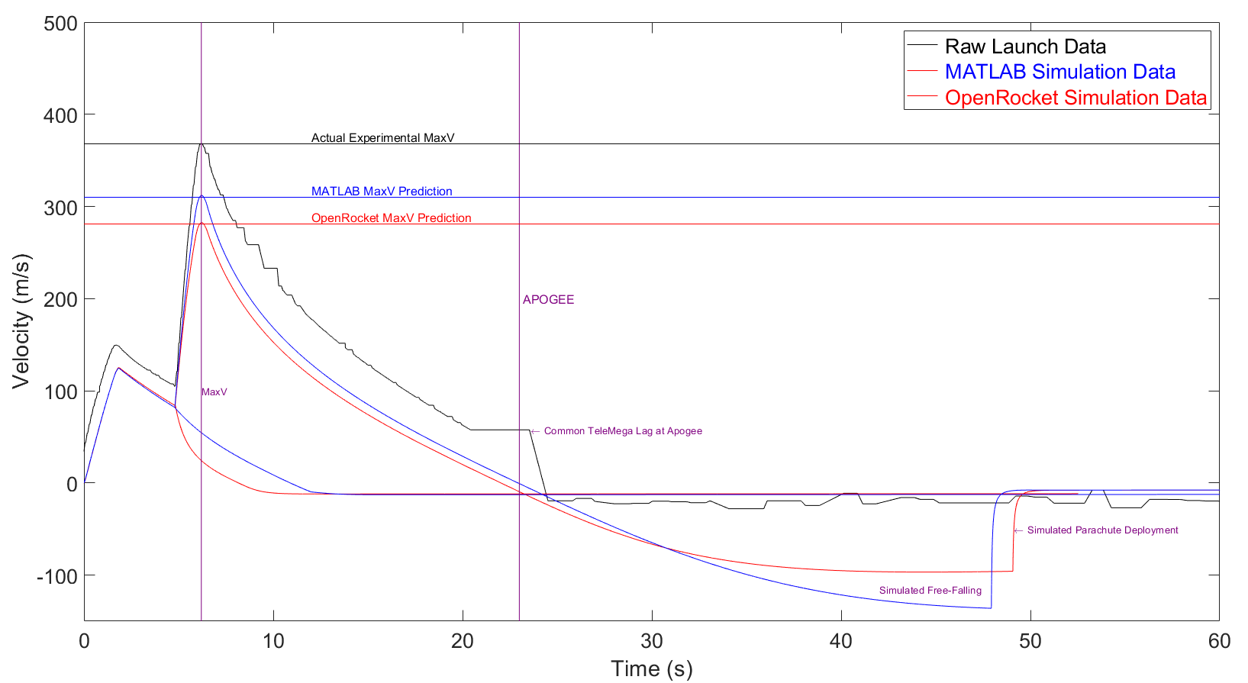

## Raw Telemega Analysis

The parachute research and testing we have completed has given us a base of knowledge that was easily

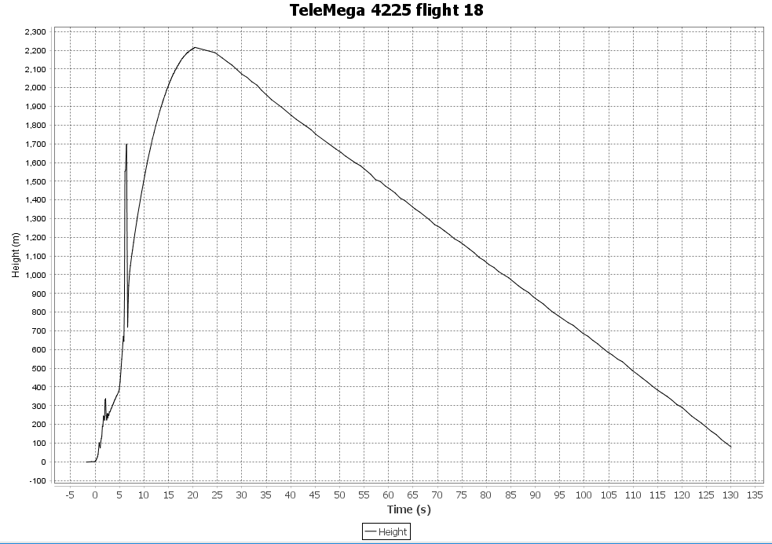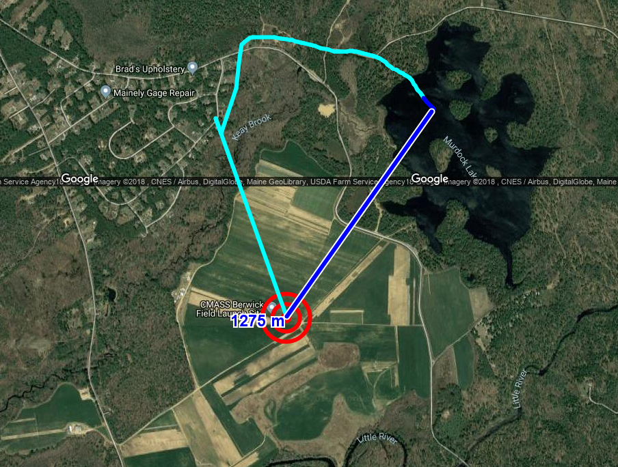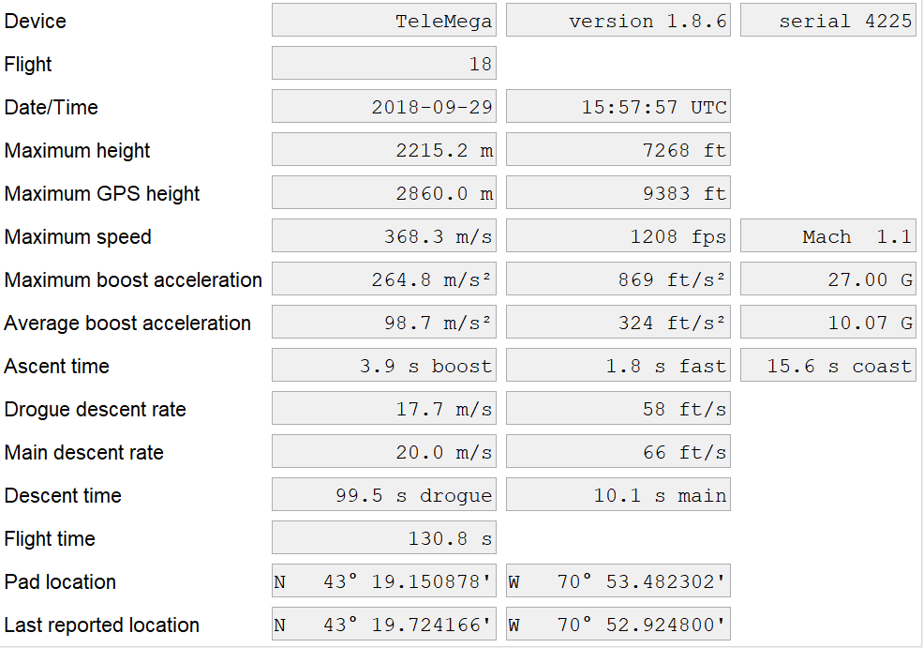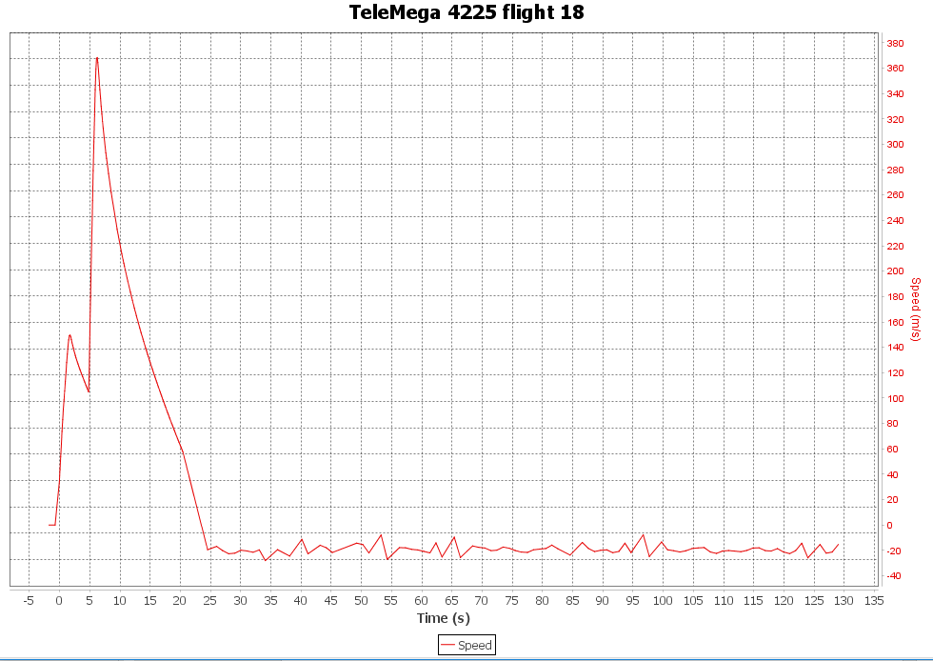

## 

# Failure Analysis

## Improvement Cycle for Failure Mitigation

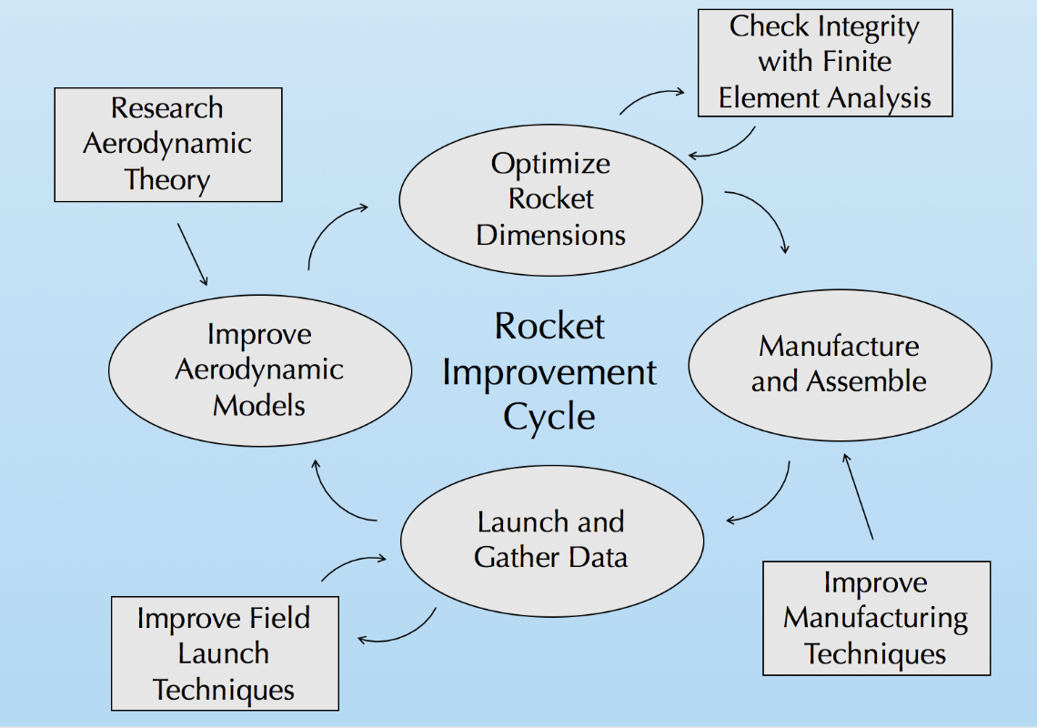

Figure 3. Improvement Cycle

Our team utilized an improvement cycle to ensure progression and improvement on each rocket iteration to ensure each flight becomes more successful and safer. The cycle begins with research of aerodynamic theory to enhance our aerodynamic models used for flight simulations. When the flight simulations are validated with experimental data, rocket dimensions are optimized for max altitude. This is done using a nonlinear optimization program in MATLAB. These dimensions are constantly checked with finite element analysis to ensure structural integrity with a minimum factor of safety of 3. This safety of factor was chosen purely to mitigate the error that we predict of a new rocket team. In the future, we would like to lower this factor of safety closer to 1.5. The rocket is then manufactured with the optimal dimensions, while working to employ better techniques from last build. After the rocket is manufactured, it is launched, and data is gathered. We are always pursuing better launch techniques to ensure recovery of all components. The data from the flight is reviewed and compared to our flight simulations, where the process then repeats.

The SEDS competition rocket is our most precise and strongest rocket ever made. It is the 9th rocket we have made, and is the last of its Aether class, Aether VII. This improvement cycle, which has been modified and improved over the 2017-2018 school year, has helped us continue to improve with each build, preventing senseless mistakes and helping us to improve.

## Competition Launch Failure Analysis

The failure of our competition rocket flight came down to two design features: the combination of our non-optimal booster engine and an insufficient launch rail length, and the fundamental change of our flight profile with the inclusion of a donated chute release for apogee separation.

Our first failure, the non-optimal booster engine and an insufficient launch rail length, directly resulted in the initial stability of our flight. With a below-desired takeoff velocity from the launch rail due to a non-optimal thrust profile, the speed was insufficient for stability to take hold. This instability at launch resulted in a flight profile that sent our rocket at an angle away from the zenith. The new booster engine was simulated before launch day, and the team decided that, although it was slightly below what we have flown in the past, there was still a good calculated chance that this speed would still work for the rocket in flight.

The second failure, which was from the fundamental change in our rocket flight profile from the addition of a donated chute release for apogee separation, caused drift (which the original flight mechanics was designed to drastically lower) pushed our rocket away from its apogee location (nearly on top of our launch pad) to over a kilometer away. This failure started from a safety standpoint on the field. As previously discussed, the launch safety officer was worried that our parachute ejection would fail, resulting in our sustainer maintaining terminal velocity, crashing back onto the field.  This change from deploying our parachute at 300 meters to 2,215 meters with a chute release resulted in incredible drift, landing the rocket over 1,000 meters away from the launch pad. However, when it comes to any launch, safety is first. If there were even a 1 percent chance that our parachute ejection would fail, it would apply risk to all the spectators watching. We willingly agreed to add the quick release to our recovery system and change the ejection to shortly after apogee. Parachute ejection was nominal shortly after apogee, sending the rocket back down at a reduced descent speed.

The culmination of our entire organization led us to this launch. Although it did not go perfectly, the failures we saw were calculated risks that needed to be taken to compete. Rocketry is a noble pursuit. It is the truest profession in which failure directly leads to success. We would like to thank SEDS for organizing this competition as it has guided us to finally become rocketeers. Multimedia Documentation

The launch took place in South Berwick, ME, on September 29th mid-day. Below are the links to the videos taken during the launch, and an assortment of pictures of the beautiful day.

## YouTube Links

The link below is the video that tracked the booster as it landed with its recovery system. Nothing broke at landing, allowing for full recoverability of our booster.

<https://youtu.be/qhKtFAfzMnM>

The link below tracked the sustainer, but quickly went out of sight as it reached its apogee. Recovery of the sustainer could not be recoded as it drifted over a kilometer into a nearby lake. Data was still collected through the Telemega transmitting to our computer on the field.

<https://youtu.be/kTArgz6VOts>

## Notable Pictures

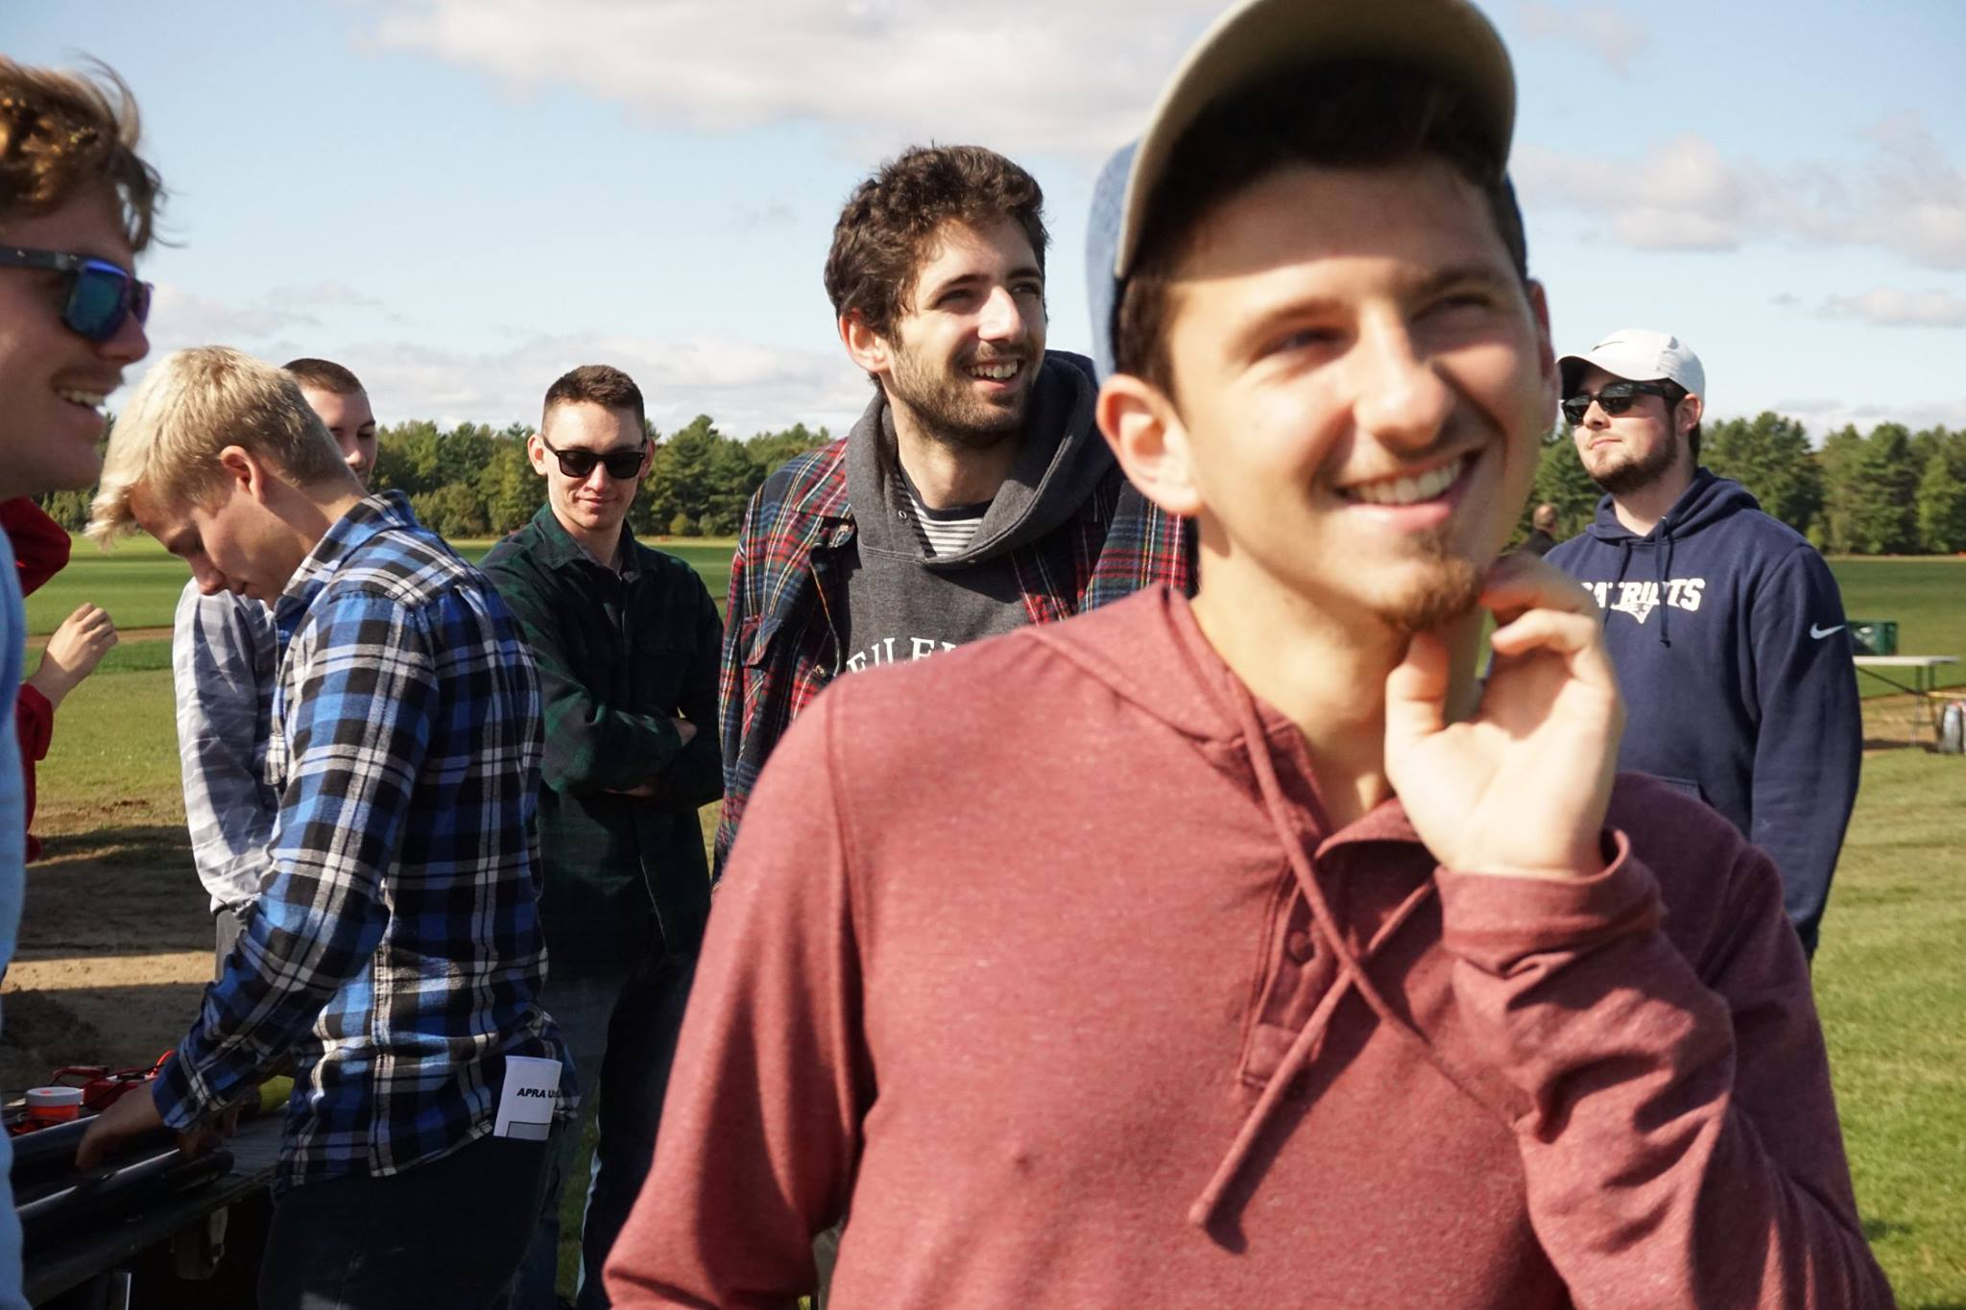

Figure 4- Team members enjoying the launch day and preparing the rocket for launch

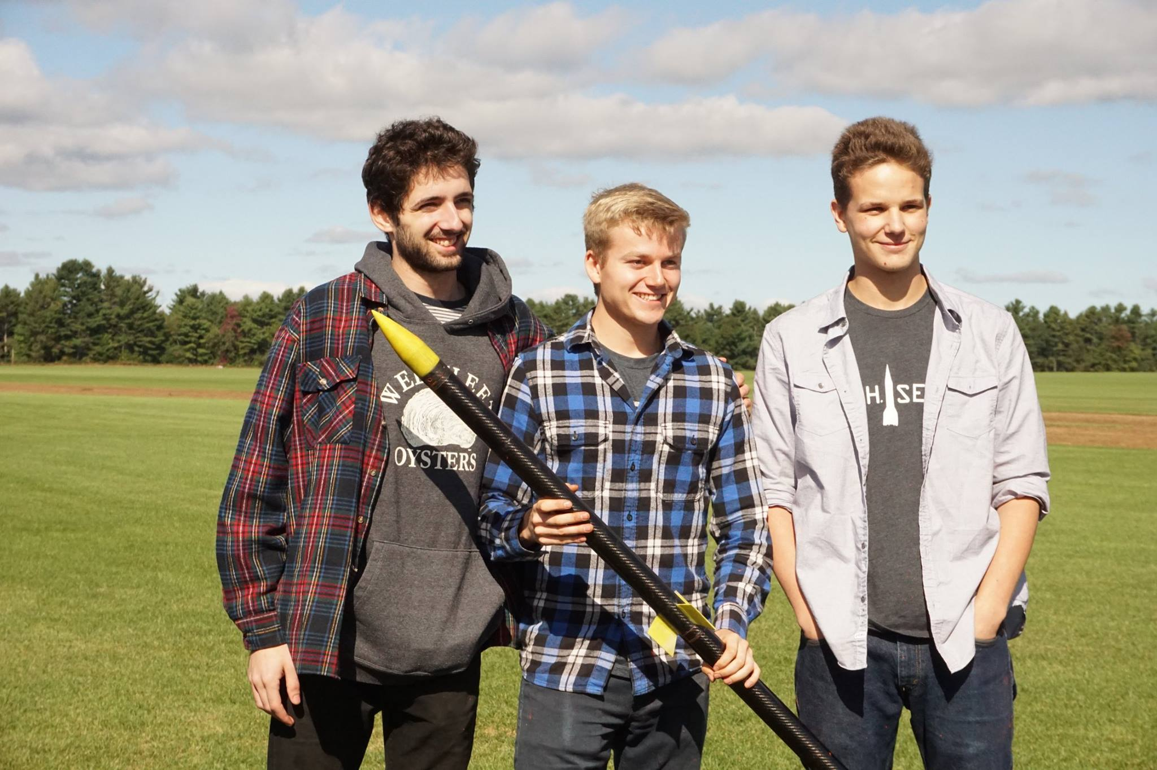

Figure 5- Engineering and building leads confirming rocket is go for launch

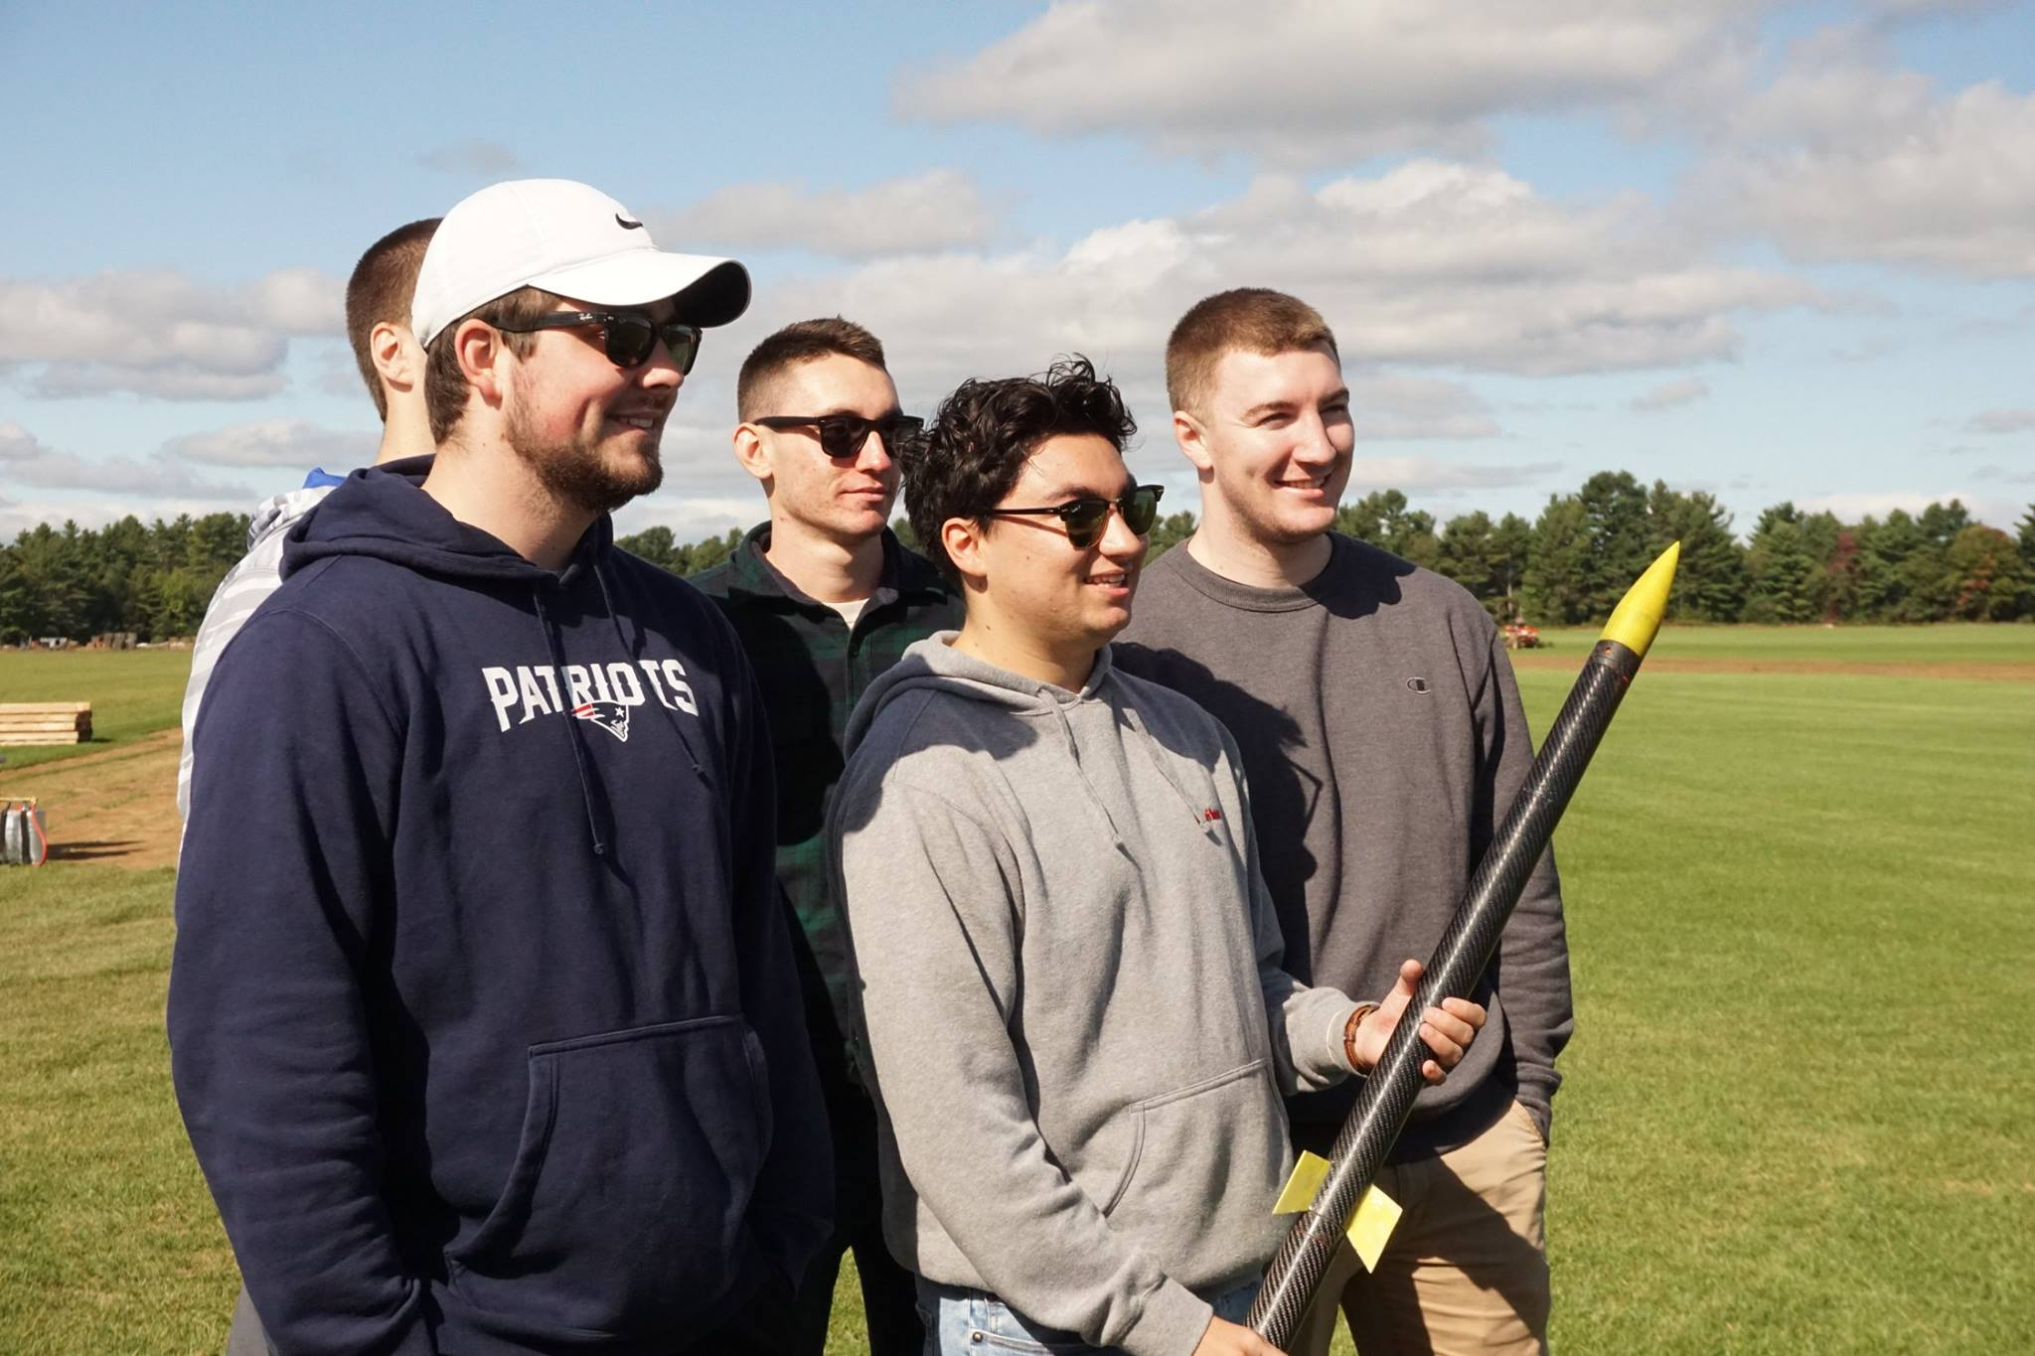

Figure 6- The new seniors of the club experiences their first rocket launch

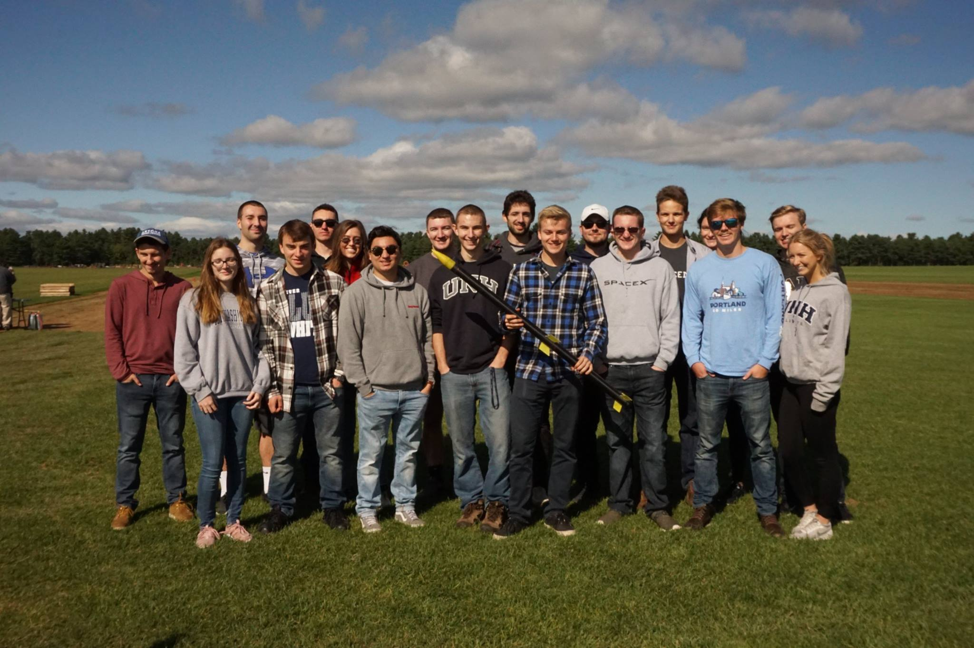

Figure 7- Full team picture as we approach our launch time

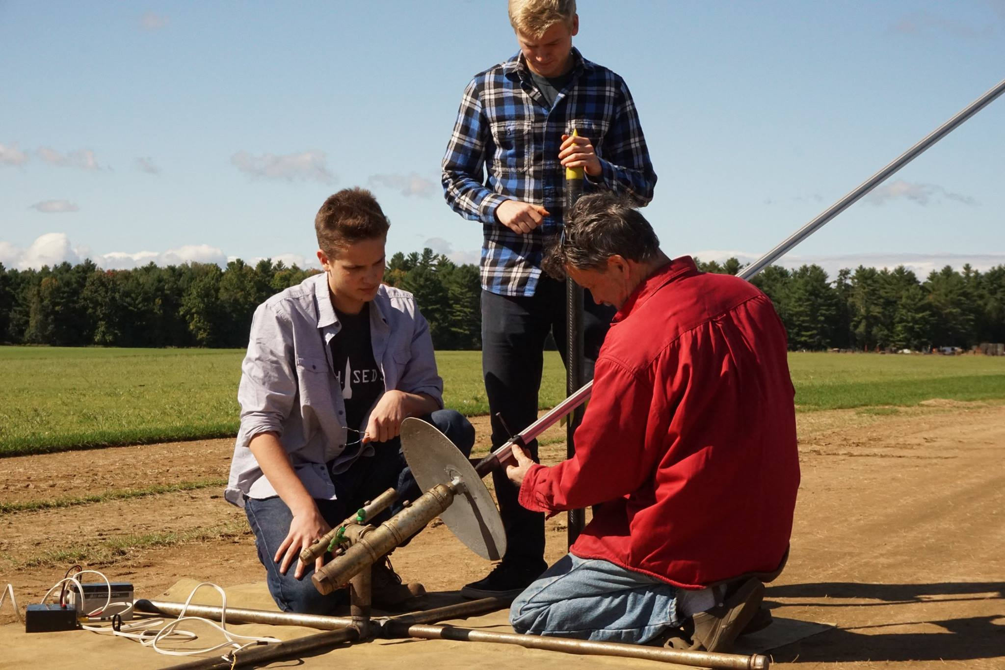

Figure 8- Attaching the multi-stage rocket to the launch pad

# APPENDIX

## MATLAB Simulation Code

The following code details the functions used to simulate a two-stage rocket with known parameters. The code can be easily manipulated with different constraints, such as stability, diameters, and masses. The code allowed the comparison of the flight data, MATLAB simulation data, and OpenRocket simulation data.

### Launch Simulation (Parent Function)

### Get Acceleration

### Get Acceleration 2

### Get Thrust

### Get Mass

### Get Drag

### Get Drag 2